**BUSINESS CASE :- Target SQL**

1. **Import the dataset and do usual exploratory analysis steps like checking the structure & characteristics of the dataset**

1.Data type of columns in a table :-

SELECT

  column_name, data_type

FROM

  model-bonsai-382608.retail_data.INFORMATION_SCHEMA.COLUMNS

  where table_name='customers'

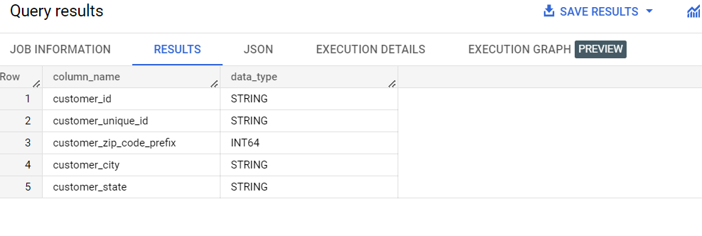

2.Time period for which the data is given:-

select min(order_purchase_timestamp) as opt1,

max(order_purchase_timestamp) as opt2 from `retail_data.orders`;

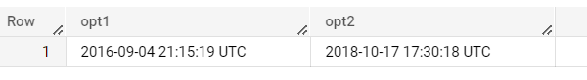

3. Cities and States of customers ordered during the given period :-

select distinct customer_city,customer_state

from  `retail_data.customers`

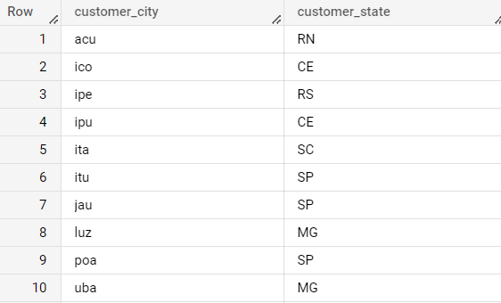

**2. In-depth Exploration**:

1. Is there a growing trend on e-commerce in Brazil? How can we describe a complete scenario? Can we see some seasonality with peaks at specific months?

SELECT

 EXTRACT (YEAR FROM order_purchase_timestamp) AS year,

 EXTRACT (MONTH FROM order_purchase_timestamp) AS month,

 COUNT(*) as num_orders

FROM `retail_data.orders`

GROUP BY year,month

ORDER BY year,month

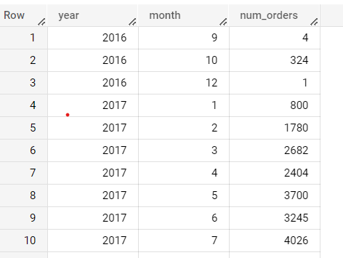

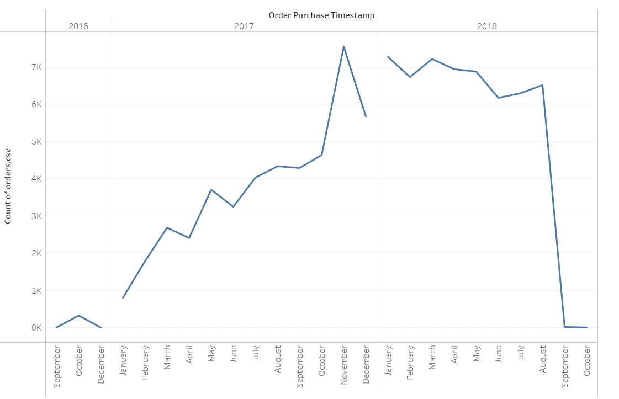

Yes, there is growing trend on e commerce in brazil.

2. What time do Brazilian customers tend to buy (Dawn, Morning, Afternoon or Night)?

SELECT

  CASE

    WHEN EXTRACT(HOUR FROM order_purchase_timestamp) >= 0 AND EXTRACT(HOUR FROM order_purchase_timestamp) < 6 THEN 'Dawn'

    WHEN EXTRACT(HOUR FROM order_purchase_timestamp) >= 6 AND EXTRACT(HOUR FROM order_purchase_timestamp) < 12 THEN 'Morning'

    WHEN EXTRACT(HOUR FROM order_purchase_timestamp) >= 12 AND EXTRACT(HOUR FROM order_purchase_timestamp) < 18 THEN 'Afternoon'

    WHEN EXTRACT(HOUR FROM order_purchase_timestamp) >= 18 AND EXTRACT(HOUR FROM order_purchase_timestamp) <= 23 THEN 'Night'

    ELSE 'Unknown'

  END AS time_period,

COUNT(*) AS num_orders

FROM `retail_data.orders`

GROUP BY time_period

ORDER BY num_orders DESC

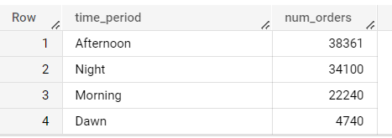

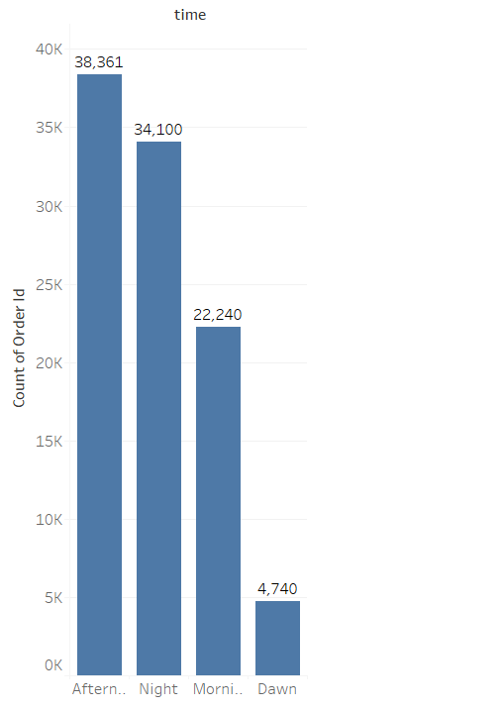

**3.Evolution of E-commerce orders in the Brazil region:**

1. Get month on month orders by states:-

SELECT

    c.customer_state,

    EXTRACT(MONTH FROM o.order_purchase_timestamp) AS month,

    COUNT(*) AS num_of_orders

FROM

    `retail_data.orders` AS o

    JOIN `retail_data.customers` AS c ON c.customer_id = o.customer_id

GROUP BY

    c.customer_state,

    month

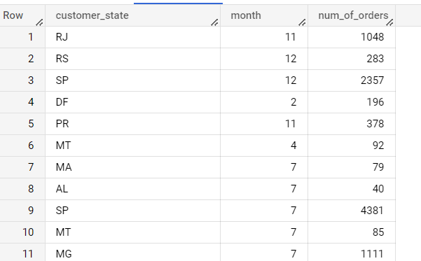

2. Distribution of customers across the states in Brazil:-

select t1.customer_state,t1.num_customers,t2.num_orders

from

(select

customer_state,count(customer_id) as num_customers from `retail_data.customers`

group by customer_state) as t1

join

(select c.customer_state,count(distinct o.order_id) as num_orders

from `retail_data.orders` o join `retail_data.customers` c on o.customer_id=c.customer_id group by c.customer_state ) as t2

on t1.customer_state=t2.customer_state

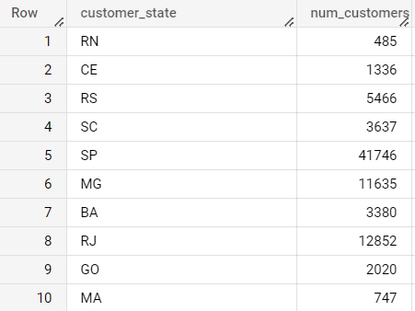

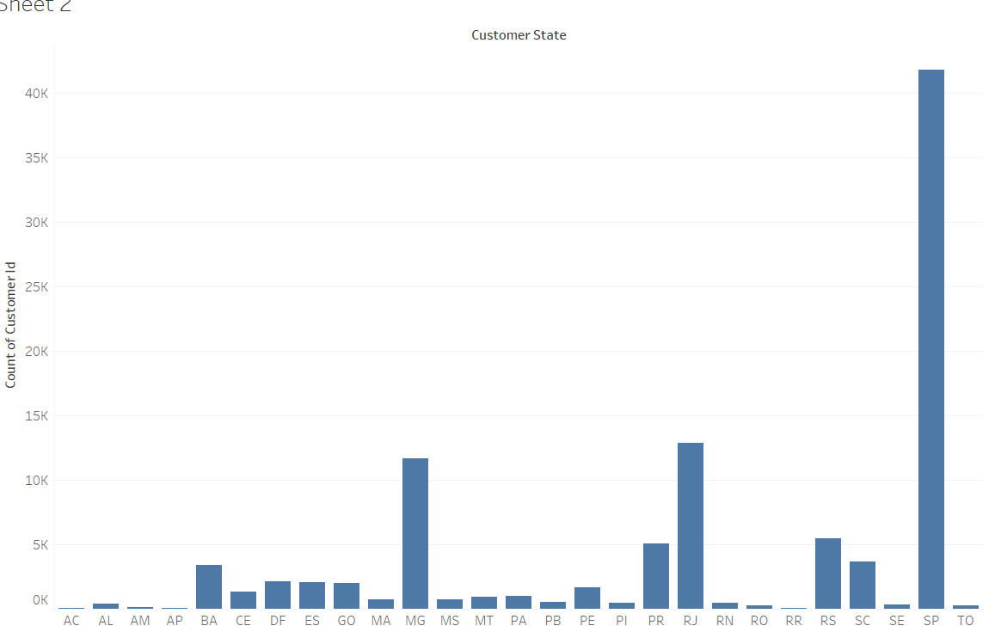

**4.Impact on Economy: Analyze the money movement by e-commerce by looking at order prices, freight and others.**

* 1. Get % increase in cost of orders from 2017 to 2018 (include months between Jan to Aug only) - You can use “payment_value” column in payments table

WITH orders_2017 AS (

  SELECT

    EXTRACT(MONTH FROM o.order_purchase_timestamp) AS month,

    round(SUM(p.payment_value),2) AS total_payment_value_2017

  FROM `retail_data.orders` o

  INNER JOIN `retail_data.payments` p ON o.order_id = p.order_id

  WHERE EXTRACT(YEAR FROM o.order_purchase_timestamp) = 2017

    AND EXTRACT(MONTH FROM o.order_purchase_timestamp) BETWEEN 1 AND 8

  GROUP BY EXTRACT(MONTH FROM o.order_purchase_timestamp)

),

orders_2018 AS (

  SELECT

    EXTRACT(MONTH FROM o.order_purchase_timestamp) AS month,

    round(SUM(p.payment_value),2) AS total_payment_value_2018

  FROM `retail_data.orders` o

  INNER JOIN `retail_data.payments` p ON o.order_id = p.order_id

  WHERE EXTRACT(YEAR FROM o.order_purchase_timestamp) = 2018

    AND EXTRACT(MONTH FROM o.order_purchase_timestamp) BETWEEN 1 AND 8

  GROUP BY EXTRACT(MONTH FROM o.order_purchase_timestamp )

)

SELECT

  o1.month,

  o1.total_payment_value_2017,

  o2.total_payment_value_2018,

  round(((o2.total_payment_value_2018 - o1.total_payment_value_2017) / o1.total_payment_value_2017) * 100,2) AS percentage_increase

FROM orders_2017 as o1

INNER JOIN orders_2018 as o2 ON o1.month = o2.month

order by o1.MONTH;

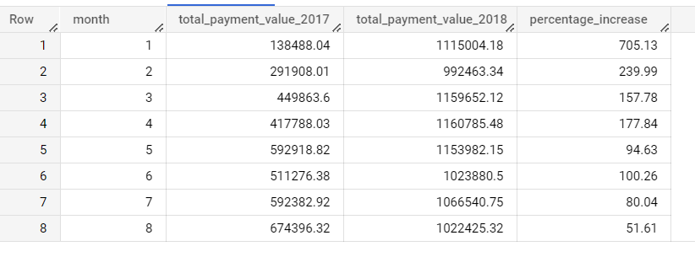

2. Mean & Sum of price and freight value by customer state

select

c.customer_state,

avg(oi.price) as mean,

sum(oi.price) as sum_of_price,

avg(oi.freight_value) as average_freight_value

from `retail_data.customers`as c  join `retail_data.orders`

as o on o.customer_id = c.customer_id

join `retail_data.order_items` as oi on oi.order_id=o.order_id

group by c.customer_state

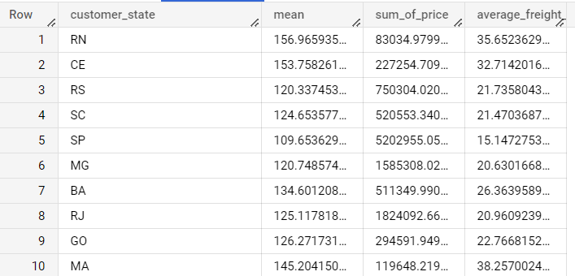

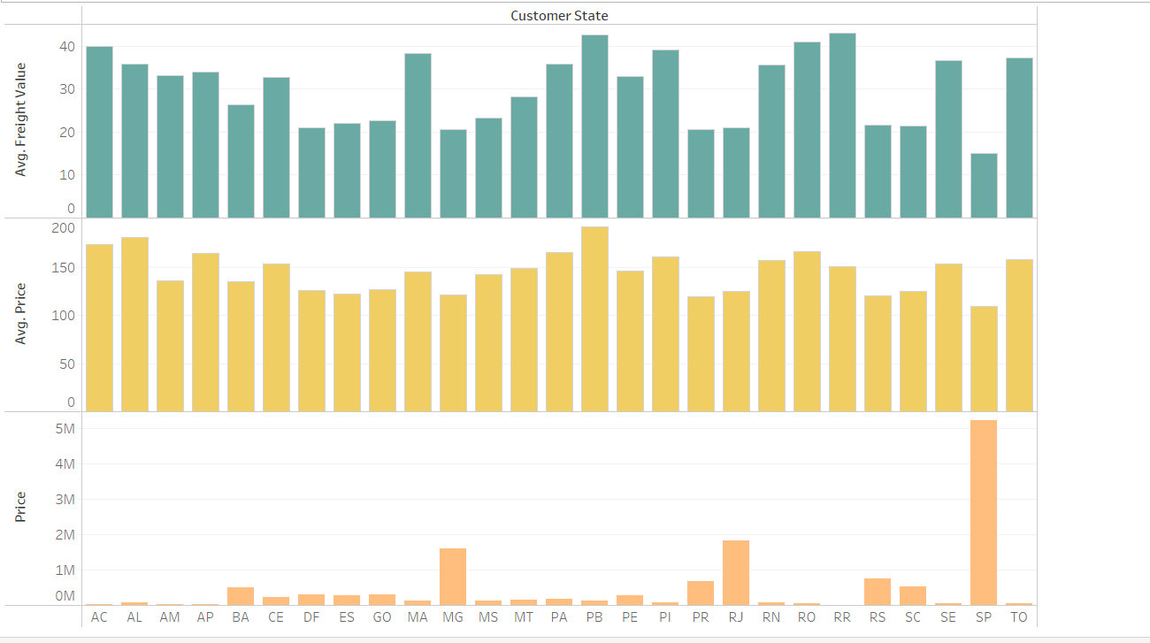

**5. Analysis on sales, freight and delivery time:-**

1. Calculate days between purchasing, delivering and estimated delivery:-

select

order_id,

DATE_DIFF(order_delivered_customer_date,order_purchase_timestamp,DAY) AS time_to_deliver,

DATE_DIFF(order_estimated_delivery_date,order_delivered_customer_date,DAY) AS time_to_estimate_deliver,

DATE_DIFF(order_estimated_delivery_date,order_delivered_carrier_date,DAY) AS time_to_estimate_deliver

from `retail_data.orders`

where order_delivered_customer_date is not null

order by time_to_deliver

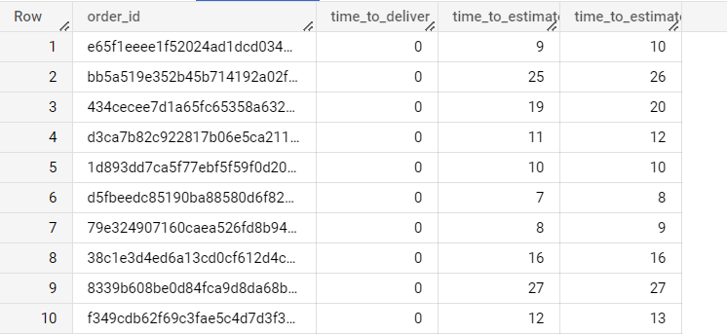

2. Find time_to_delivery & diff_estimated_delivery. Formula for the same given below:

* + time_to_delivery = order_purchase_timestamp-order_delivered_customer_date
  + diff_estimated_delivery = order_estimated_delivery_date-order_delivered_customer_date

select

abs(DATE_DIFF(order_purchase_timestamp,order_delivered_customer_date,day)) as time_to_delivery,

abs(date_diff(order_estimated_delivery_date,order_delivered_customer_date,day)) as diff_estimated_delivery

from `retail_data.orders`

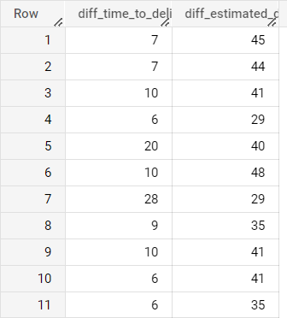

3. Group data by state, take mean of freight_value, time_to_delivery, diff_estimated_delivery

select

c.customer_state,

round(avg(oi.freight_value),2) as mean,

round(Avg(date_diff(o.order_delivered_customer_date,o.order_purchase_timestamp,day)),2) as time_to_delivery,

round(avg(date_diff(o.order_estimated_delivery_date,o.order_delivered_carrier_date,day)),2) as time_for_estimated_delivery

from `retail_data.customers` as c

 join `retail_data.orders` as o on c.customer_id=o.customer_id

join `retail_data.order_items` as oi on oi.order_id=o.order_id

group by c.customer_state

order by mean

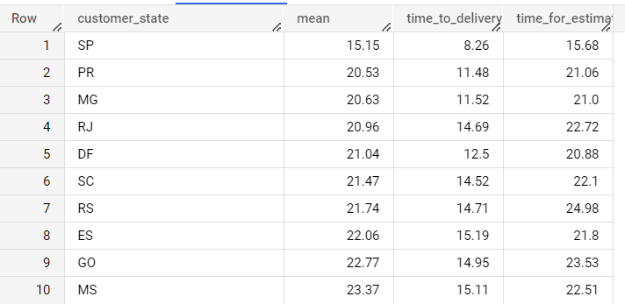

4.Sort the data to get the following:

5.Top 5 states with highest/lowest average freight value - sort in desc/asc limit 5

HIGHEST AVERAGE FREIGHT VALUE

select c.customer_state,AVG(oi.freight_value) as avg_freight

from `retail_data.orders` as o

join `retail_data.customers` as c on c.customer_id=o.customer_id

join `retail_data.order_items` as oi on oi.order_id=o.order_id

group by c.customer_state

order by avg_freight desc

limit 5

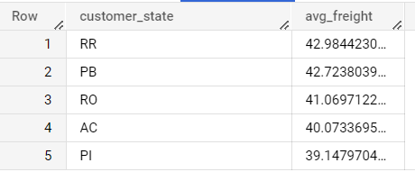

LOWEST AVERAGE FREIGHT VALUE

select c.customer_state,AVG(oi.freight_value) as avg_freight

from `retail_data.orders` as o

join `retail_data.customers` as c on c.customer_id=o.customer_id

join `retail_data.order_items` as oi on oi.order_id=o.order_id

group by c.customer_state

order by avg_freight ASC

limit 5

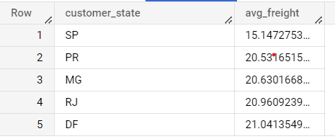

6.Top 5 states with highest/lowest average time to delivery

HIGHEST AVERAGE TIME FOR DELIVERY

select c.customer_state,AVG(date_diff(o.order_delivered_customer_date,

o.order_purchase_timestamp,day)) as time_to_delivery

from `retail_data.orders` as o

join `retail_data.customers` as c on c.customer_id=o.customer_id

group by c.customer_state

order by time_to_delivery desc

limit 5

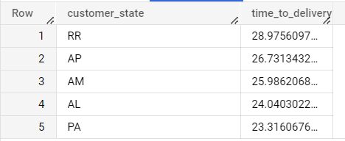

LOWEST AVERAGE TIME FOR DELIVERY

select c.customer_state,AVG(date_diff(o.order_delivered_customer_date,

o.order_purchase_timestamp,day)) as time_to_delivery

from `retail_data.orders` as o

join `retail_data.customers` as c on c.customer_id=o.customer_id

group by c.customer_state

order by time_to_delivery desc

limit 5

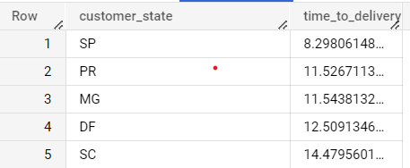

7. Top 5 states where delivery is really fast/ not so fast compared to estimated date

WITH delivery_time AS (

  SELECT

    c.customer_state,

    CASE

      WHEN o.order_delivered_customer_date <= o.order_estimated_delivery_date THEN 'Fast Delivery'

      ELSE 'Not so Fast Delivery'

    END AS delivery_status,

  FROM `retail_data.orders` as o join `retail_data.customers` as c on o.customer_id=c.customer_id

  WHERE o.order_delivered_customer_date IS NOT NULL

  GROUP BY c.customer_state, delivery_status

),

delivery_times_rank AS (

  SELECT

    customer_state,

    delivery_status,

    ROW_NUMBER() OVER (PARTITION BY delivery_status ) AS rank_of

  FROM delivery_time

)

SELECT

  customer_state,

  delivery_status,

FROM delivery_times_rank

WHERE rank_of <= 5

ORDER BY delivery_status desc

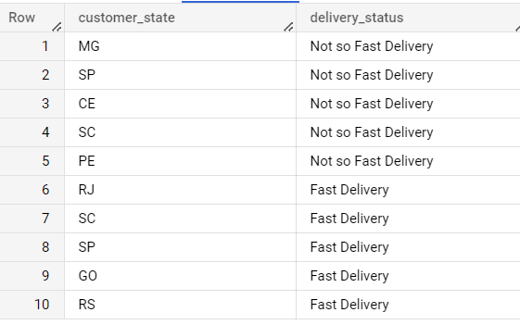

**6. Payment type analysis:**

1. Month over Month count of orders for different payment types:-

SELECT

  p.payment_type,

  EXTRACT(MONTH from o.order_purchase_timestamp) AS month,

  count(*) AS order_count

FROM

  `retail_data.orders` as o

JOIN `retail_data.payments` p ON o.order_id = p.order_id

GROUP BY

p.payment_type,

  month

ORDER BY

  order_count desc

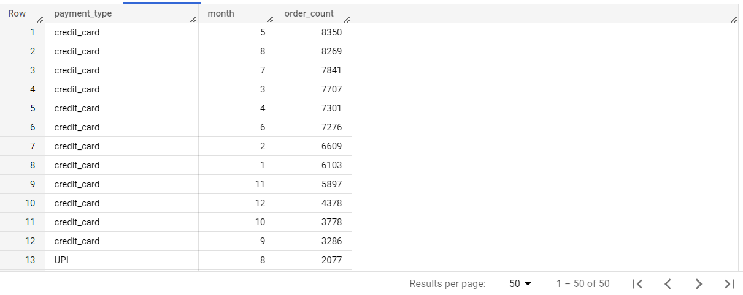

We can see that orders are more ordered by payment type credit card

1. Count of orders based on the no. of payment installments

select payment_installments,count(order_id) as num_of_orders

from `retail_data.payments` as p

group by payment_installments

